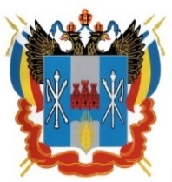
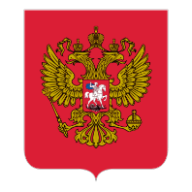
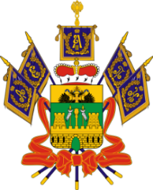
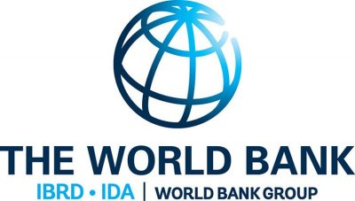
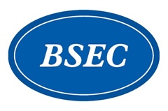
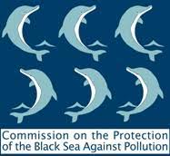
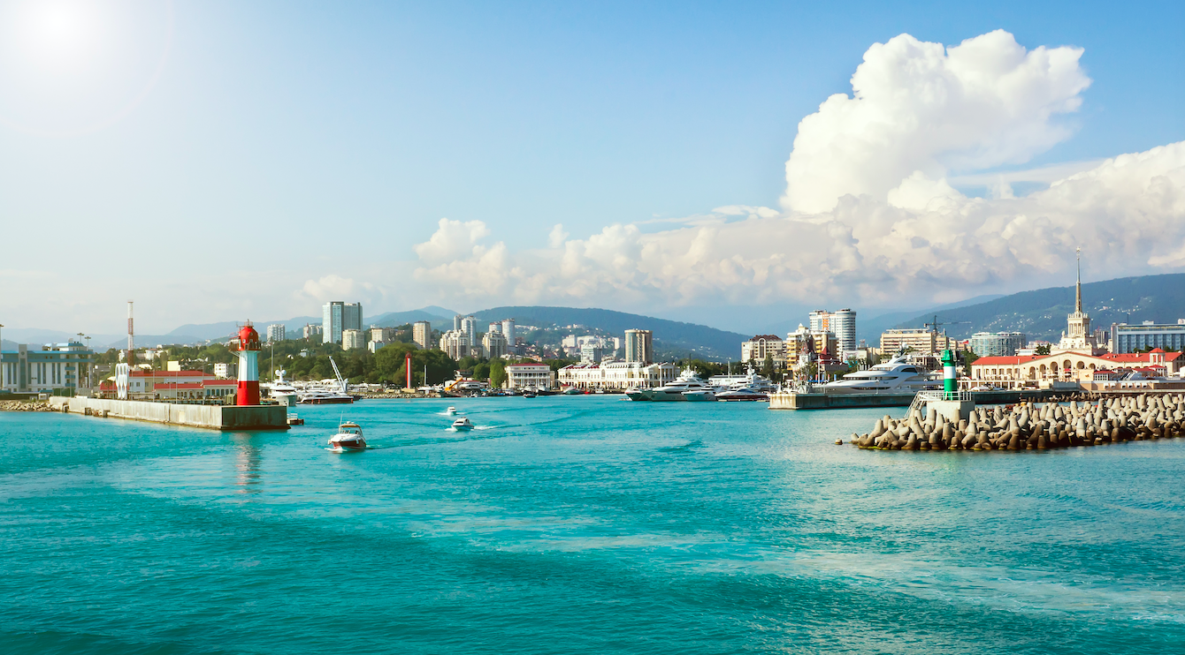

Stakeholder Webinar

CONSULTATIONS ON
THE DESIGN OF BLUEING THE BLACK SEA PROGRAMME -
A REGIONAL INITIATIVE
TO TACKLE MARINE POLLUTION AND CLIMATE CHANGE IN SUPPORT OF
THE COMMON MARITIME AGENDA FOR THE BLACK SEA

Friday, 1st October 2021, 12.00 (Moscow, UTC+3)
Online with simultaneous translation

Friday, 1 October 2021
12:00 – 12:30 | WELCOME ADDRESSES
Moderator: | - Ms. Vladislava NEMOVA, Environmental Specialist, Moscow Country Office World Bank
Speakers: | - H.E. Amb. Lazăr COMĂNESCU, Secretary General, Permanent International Secretariat (PERMIS), Organization of the Black Sea Economic Cooperation (BSEC)  - H.E. Mr. Sergey IERIOMIN, Minister of Natural Resources of the Krasnodar Region  - Mr. Renaud SELIGMANN, World Bank Country Director
 | * * * FAMILY PHOTO * * *
12.30 – 13.00 | INTRODUCTION: A REGIONAL RESPONSE FOR THE BLUE ECONOMY
Moderator: | - Ms. Patrizia BUSOLINI, Policy Officer, Black Sea, DG MARE
Presentations: | - Overview of the CMA, SRIA  - Mr. Piotr ZAVIALOV, Deputy Director of the Shirshov Institute of Oceanology of Russian Academy of Sciences, DSc (Geographical Sciences), Corresponding Member of RAS  - Mr. Igor KAPYRIN, Deputy Director of the European Cooperation Department of the Ministry of Foreign Affairs of the Russian Federation  - Overview of and BBSEA Program  - Ms. Bérengère PRINCE, Lead Natural Resources Management Specialist, World Bank
13.00 – 13.25 | SESSION 1: IMPROVING KNOWLEDGE OF THE POLLUTION IN THE BLACK SEA
Moderator: | - Ms. Iryna MAKARENKO, Pollution Monitoring and Assessment Officer, Commission on the Protection of the Black Sea Against Pollution
Presentations | - Pollution Monitoring  - Mr. Alexander KORSHENKO, PhD (Biology), Head of Marine Pollution Monitoring Lab. of the N.N. Zubov State Oceanographic Institute  - Turning the Tide of Pollution  Turning the Tide of Pollution is an Analytical Work to establish an up-to-date diagnostic of the state of play and the issues at stake regarding marine pollution in the Black Sea on the example of the efforts of the coastal countries. Through a targeted discussion, the panel will aim to identify the sources, impacts, and prevention efforts (information and institutional gaps) related to marine pollution in the Black Sea basin. The findings will feed into a regional level pollution diagnostic paper, which, in turn, will inform the BBSEA program.  - Mr. Nicola BERTOLINI, BBSEA Pollution Expert, Manager, Ambiente SPA
 | Poll and Q & A Session
13.25 – 13.50 | SESSION 2: DESIGNING RESPONSES TO TACKLE POLLUTION IN THE BLACK SEA
Moderator: | - Ms. Gulana Enar HAJIYEVA, Senior Environmental Specialist, World Bank
Presentations | - Ecosystem approach in maritime activities in the Russian Federation  - Mr. Alexey KONOVALOV, PhD, Deputy Director of the Institute for National Marine Policy Integrated Study RTU-MIREA.  - BBSEA Regional Project currently under preparation  This presentation will centre on the investment component of the planned BBSEA – a regional project funded by the Global Environmental Facility (GEF). The discussion will contribute to the understanding of the priorities of public authorities and private stakeholders with respect to the overall project and its parts and to the promotion of eco-sustainable business practices, innovation, and finance that support pollution reduction. The session will touch upon avenues to involve financial institutions in funding and promoting green technology investments, focusing on pollution reduction.  - Ms. Rositsa STOEVA, Executive Manager, BSEC PERMIS
 | Poll and Q & A Session
13.50 – 14.00 | WRAP-UP OF THE DISCUSSIONS AND CLOSING REMARKS
Speakers: | - Ms. Paola AGOSTINI, Lead Natural Resources Management Specialist, World Bank  - Mr. Igor KAPYRIN, Deputy Director of the European Cooperation Department of the Ministry of Foreign Affairs of the Russian Federation

