

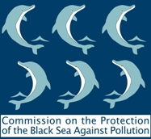
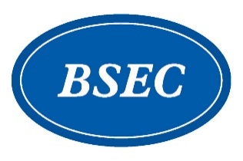

TOWARDS A
‘BLUEING THE BLACK SEA PROGRAMME’
A REGIONAL INITIATIVE TO TACKLE MARINE POLLUTION IN THE BLACK SEA

4 February 2021, Online

REGISTRATION FORM

This form should be filled in and returned to the BSEC PERMIS
(evgenia@bsec-organization.org) not later than 1 February 2021

I. PARTICIPANTS’ DETAILS

Country:
Title: | Mr. Ms.
First name:
Surname:
Organization:
Position:
Working telephone (with area code):
E-mail:

