****[](https://www.worldbank.org/)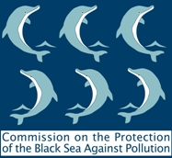**[](http://www.bsec-organization.org/)**

**TOWARDS A**

**‘BLUEING THE BLACK SEA PROGRAMME’**

***A REGIONAL INITIATIVE TO TACKLE MARINE POLLUTION IN THE BLACK SEA***

**4 February 2021, Online**

**REGISTRATION FORM**

**This form should be filled in and returned to the BSEC PERMIS   
(**[**evgenia@bsec-organization.org**](mailto:evgenia@bsec-organization.org)**) not later than 1 February 2021**

**I. PARTICIPANTS’ DETAILS**

|  |  |
| --- | --- |
| ***Country:*** |  |
| ***Title:*** | **Mr. Ms.** |
| ***First name:*** |  |
| ***Surname:*** |  |
| ***Organization:*** |  |
| ***Position:*** |  |
| ***Working telephone (with area code):*** |  |
| ***E-mail:*** |  |